SUMMARY OF SURVEY RESULTS
The following survey was hosted on the City’s website from March 30 to May 2, 2016. Written responses to open-ended questions were compiled and sorted into categories that best represent the feedback received.

Question 1: Are you a downtown business owner?

911 responses
- Yes – 68
- No – 843

Question 2: How often do you visit downtown?

913 responses
- 40% Daily
- 36% 1 - 3 times a week
- 12% I work downtown
- 9% 1 – 3 times a month
- 3% Less than once a month

799 of 920 who completed the survey indicated that they visit downtown regularly.

Question 3: Why do you go downtown? (choose all that apply)

877 responses
- 92% Shopping
- 75% Dining
- 73% Banking
- 39% Recreation
- 35% Arts and culture
- 25% Health Services
- 13% Legal Services
- 2% I live downtown
Question 4: What is your favourite thing about downtown (a strength to build on)?
Actual comments from the survey have been sorted into general categories and listed below:

Identity – 291 responses
- Love the waterfront access and exposure.
- We have amazing views of the ocean and mountains

Streetscape – 240 responses
- Love all the trees, flowers and greenery.
- Everything close together
- The landscaping

Business and Shopping – 121 responses
- Love the unique shops and the variety available.
- Art gallery and Tidemark

Transportation – 89 responses
- Free and easy parking.
- Everything in walking distance.

Food and Entertainment – 62 responses
- Spirit square and the activities put on there.
- Restaurants with patios/ocean views.
- Street events

Other – 27 responses
- Nothing
- It has potential

Question 5: What do you dislike most about downtown (first thing to improve)?

Actual comments from the survey have been sorted into general categories and listed below:

Identity – 242 responses
- Buildings and storefronts are run-down
- Dirty and drab. We need more color.
- Area around the 13th Ave and Shoppers Row needs to be updated.
- Downtown is too spread out.

Transportation – 224 responses
- Parking (80 comments on various issues)
- Poor traffic flow. Too many 4 way stops.
- Pedestrian crosswalks are dangerous.
- Tyee plaza parking lot is not attractive. Would like to see broken up with flowers/trees/shops.
- Lack of bike lane and bike racks.

Business and Shopping – 166 responses
- Need more shops to attract tourists. Lack of options.
- Shops are closed to early.
- Need to expand retail and business uses in addition to banks and real estate offices
- Too many empty shops.
- Store fronts need to be updated.

Safety and Homelessness – 147 responses
- People drinking and taking drugs on the streets make it unsafe in areas.
- The homeless issue.
- Panhandlers
- 13th and Shoppers Row is an unsafe area to walk by.

Streetscape – 75 responses
- Inconsistency – no common feel from block to block.
- Dark and unfriendly at night. Need more lights.
- The big trees need to be removed.
- Need benches for people to stop and rest.
- Street signs needed.
- More greenspace. More flowers and trees needed.

Food and Entertainment – 72 responses
- Lack of restaurants and pubs
- Everything closing too early
- We need more places with patios
- We need more places on the waterfront

Waterfront – 24 responses
- Nothing
- Empty lot behind old Target needs to be developed.
- Need more waterfront dining options.
- Access to Tyee plaza from waterfront.

Question 6: Which elements of the streetscape do you think are important for downtown revitalization? CHOOSE FIVE OPTIONS.

912 responses

- 60% Outdoor Seating (eg. bistro seating on sidewalk, outside of cafes)

- 48% Street Trees
- 46% Planter beds/street landscaping/hanging baskets
- 43% Street furniture

- 38% Parking within walking distance of retail areas (eg. well placed parking lots)
- 38% Lighting (decorative lighting, streetlights, artistic illumination)
- 36% Designated food vendor spots
- 31% Public Art

- 29% Wide sidewalks
- 25% Informal live music / busking
- 25% Alley way treatment (eg. creating interesting walking areas though alleyways)
- 24% Window displays and signs (storefronts creating a more interesting and attractive presentation to the street)
- 24% Bike Paths
- 22% Building colour
- 22% Coordinated signs (eg. common look/style for downtown businesses)
- 21% Awnings. canopies over sidewalks
- 21% Play equipment/activity for children

- 19% Crosswalk treatment (eg. line painting/flashing lights)
- 16% Clutter-free streets (removal of most vehicle traffic signs and markings)
- 11% Bike or scooter parking
- 10% Gateway features (eg. entrance arches/signs)
- 10% Wayfinding signs (eg. maps/directional signs)
- 10% Other

Other – 95 responses
- A common theme for downtown.
- Live music.
- Pedestrian/bike friendly.
- Fruit Trees.
- Something for the homeless.

Question 7: Which area(s) of the downtown do you think the City should focus on for streetscape improvements? Please rank these five locations (#1 should be your highest priority).

891 responses

- 1st - Shoppers Row (from St. Ann’s Rd to 16th Ave/Dogwood)
- 2nd - Pier Street (from Robert Ostler Park to the Maritime Heritage Museum)
- 3rd - Island Hwy19A (from Robert Ostler Park to Robert’s Reach)
- 4th - Court House Area (including 13th/14th; Cedar Street and Cypress Street)
- 5th - Beech Street/Cedar Street (including 10th/11th Ave)

Question 8: Which design themes should the City focus on in the downtown?

Other – 73 Responses
- Combination of West Coast & Maritimes. West Coast theme with bright colors.
- Combination of West Coast & First Nations.
- *Combination of West Coast & Historic Marine.

Question 9 – Which of the streetscapes below are your favourite look for downtown Campbell River? Rank these images, with #1 being your favourite.

- 1st – Pedestrian streetscape
- 2nd – Tree canopy
- 3rd – Sidewalk activity
- 4th – Mixed use
- 5th – Lighting and atmosphere
- 6th – Cycle streetscape

The following pictures were used in the survey to represent various streetscapes:

1st – Pedestrian Streetscape

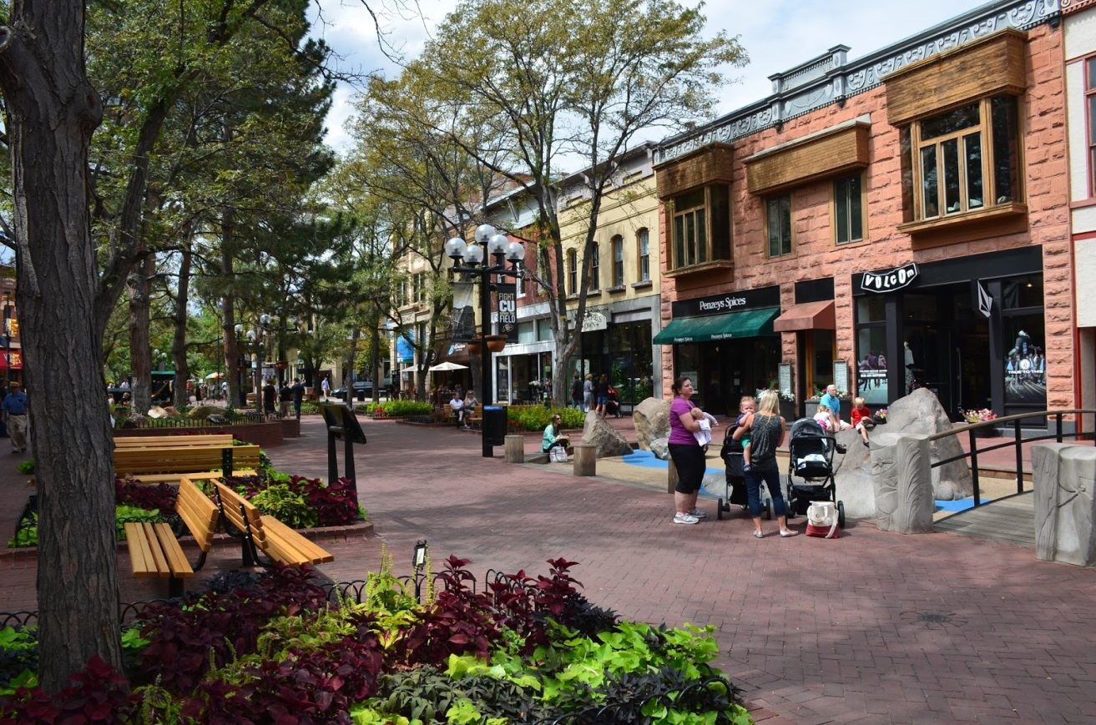

2nd – Tree Canopy Streetscape

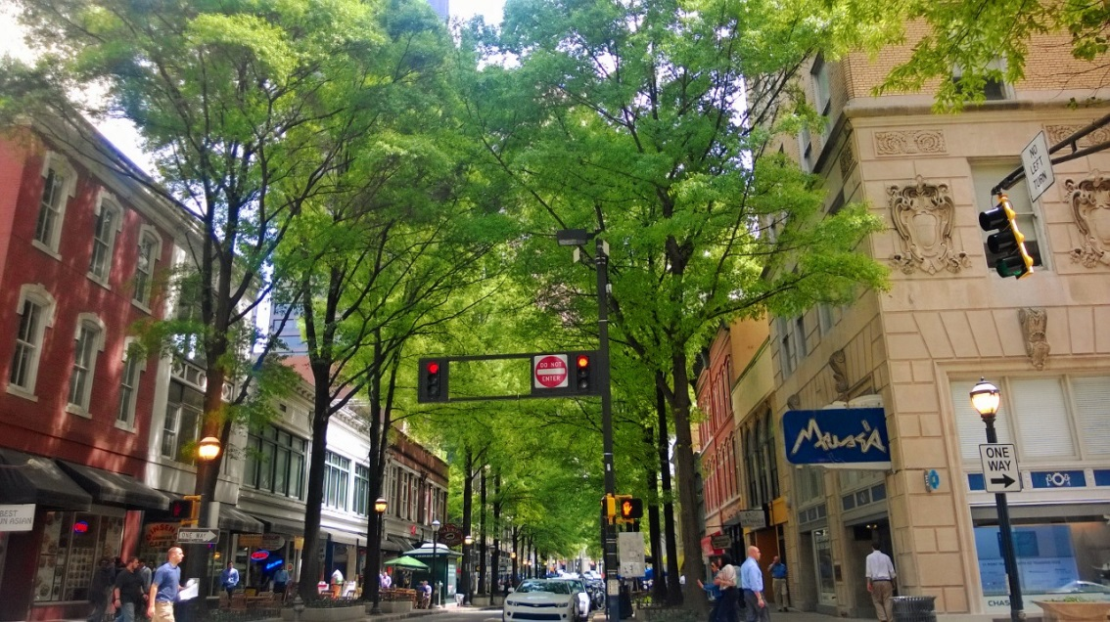

3rd – Sidewalk Activity Streetscape

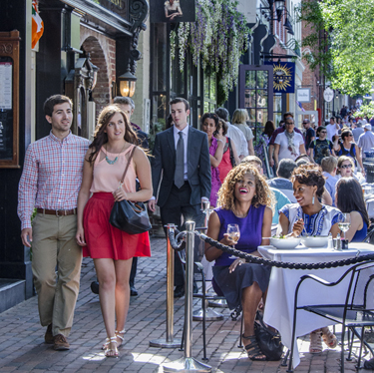

4th – Sidewalk Activity Streetscape

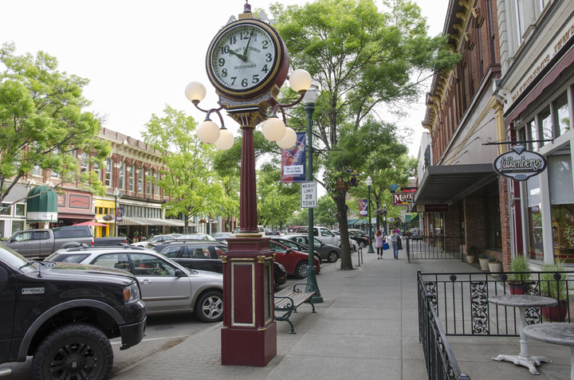

5th – Lighting and Atmosphere Streetscape

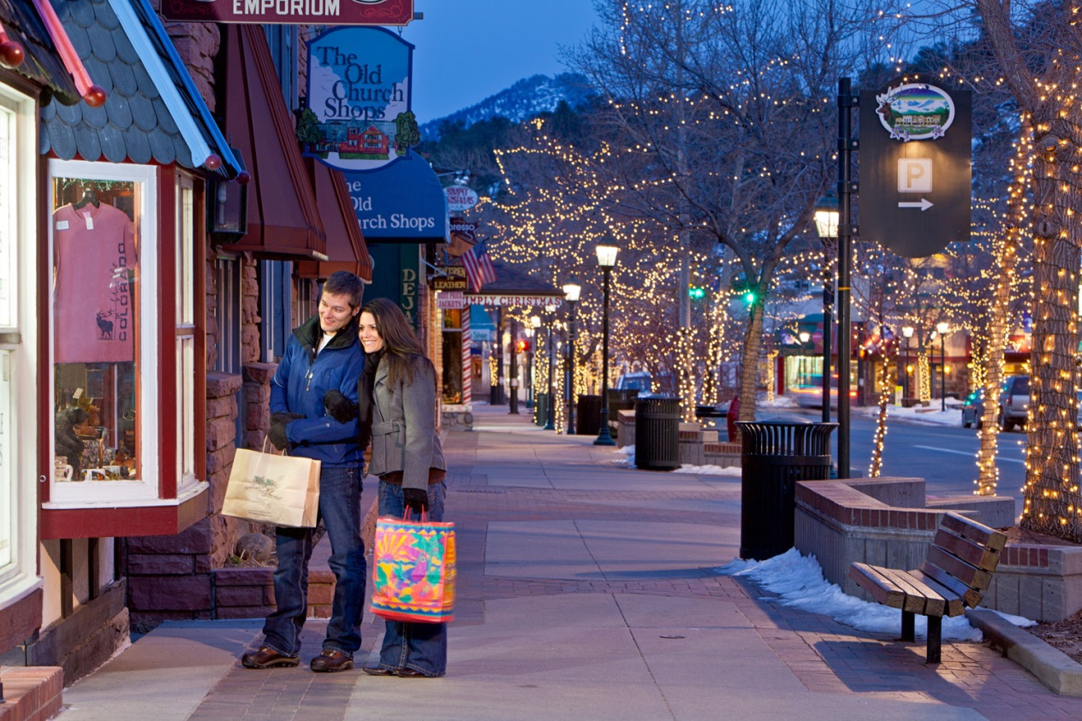

6th – Cycle Streetscape

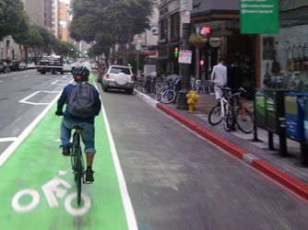

Question 10 – Which type of sign would you like to see more of in the downtown? Rank these images, with #1 being your favourite.

- 1st – Hanging Sign
- 2nd – Awning Sign
- 3rd – Fascia Sign
- 4th – Monument Sign
- 5th – Sandwich Sign

The following pictures were used in the survey to represent various streetscapes:

1st – Hanging Sign

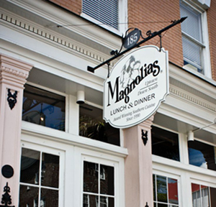

2nd – Awning Sign
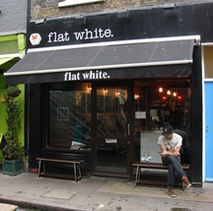
3rd – Facia Sign

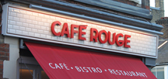

4th – Monument Sign

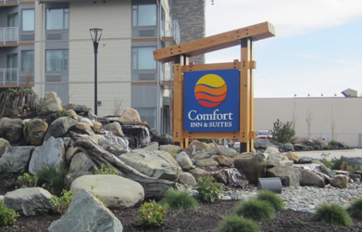

5th – Sandwich Sign

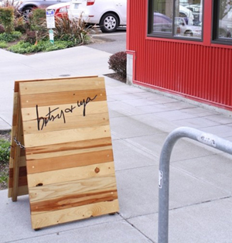
Question 11: Are there any events or programs the City could offer to attract more people downtown?

Music and Festivals – 308 responses
- Music festival or concerts.
- Festivals - buskers/food/cultural.
- More events at Spirit Square.

Food – 93 responses
- Want food trucks and food vendors.
- Beer gardens.
- Food Festivals

Sports – 17 responses
- A sports day.
- Host annual 5 thru 8 km walk/run.

Markets – 64 responses
- More markets
- Street markets with road closures
- Mid-week farmers market
Family Events – 37 responses
- More family friendly events.
- Kids concerts.

Arts and Culture – 24 responses
- Showcase local artists.
- Multicultural events.

Other – 93 responses
- More shopping and stores staying open later.
- Program to help with the homeless.

Question 12: Please share any other suggestions you have for improvements downtown.

Actual comments from the survey have been sorted into general categories and listed below:

Identity – 124 responses
- Garbage needs to be cleaned up off the streets
- Building need to have a fresh, clean look. Add color
- More housing downtown - possibly above businesses

Business and Shopping – 90 responses
- More unique shops – less banks and real estate offices
- Add residences above businesses
- Longer business hours
- A conference centre

Food and Entertainment – 83 responses
- More options for food and beverages. Brew pubs.
- Food trucks and food vendors
- Better nightlife
- More outdoor events – live music

Safety and Homelessness – 74 responses
- Place for homeless to go
- More policing
- Make downtown safer

Transportation – 72 responses
- Parking – More parking, no pay parking, time limits on parking
- Bike lane and bike parking

Streetscape – 70 responses
- More lighting
- Less vehicle traffic and more pedestrian based
- Less concrete, more greenery

Waterfront – 24 responses
- Need to develop the lot behind Target. Plant trees or park with benches for people to enjoy the waterfront.
- Boat launch

